Burkina Faso

## Population Data

The data set shows the political stability estimate of the country each year.

## # A tibble: 23 x 5  
## country iso3c date population popCategory5  
## <chr> <chr> <dbl> <dbl> <chr>   
## 1 Burkina Faso BFA 1996 10372745 small   
## 2 Burkina Faso BFA 1997 10665546 small   
## 3 Burkina Faso BFA 1998 10968724 small   
## 4 Burkina Faso BFA 1999 11282701 small   
## 5 Burkina Faso BFA 2000 11607942 small   
## 6 Burkina Faso BFA 2001 11944587 small   
## 7 Burkina Faso BFA 2002 12293100 small   
## 8 Burkina Faso BFA 2003 12654621 small   
## 9 Burkina Faso BFA 2004 13030569 small   
## 10 Burkina Faso BFA 2005 13421930 small   
## 11 Burkina Faso BFA 2006 13829176 small   
## 12 Burkina Faso BFA 2007 14252021 small   
## 13 Burkina Faso BFA 2008 14689725 small   
## 14 Burkina Faso BFA 2009 15141098 small   
## 15 Burkina Faso BFA 2010 15605217 small   
## 16 Burkina Faso BFA 2011 16081911 small   
## 17 Burkina Faso BFA 2012 16571246 small   
## 18 Burkina Faso BFA 2013 17072775 small   
## 19 Burkina Faso BFA 2014 17586017 small   
## 20 Burkina Faso BFA 2015 18110624 small   
## 21 Burkina Faso BFA 2016 18646378 small   
## 22 Burkina Faso BFA 2017 19193284 small   
## 23 Burkina Faso BFA 2018 19751535 small

## # A tibble: 23 x 5  
## country iso3c date popGrowth popGrowthCat5   
## <chr> <chr> <dbl> <dbl> <chr>   
## 1 Burkina Faso BFA 1996 2.76 high growth rate  
## 2 Burkina Faso BFA 1997 2.78 high growth rate  
## 3 Burkina Faso BFA 1998 2.80 high growth rate  
## 4 Burkina Faso BFA 1999 2.82 high growth rate  
## 5 Burkina Faso BFA 2000 2.84 high growth rate  
## 6 Burkina Faso BFA 2001 2.86 high growth rate  
## 7 Burkina Faso BFA 2002 2.88 high growth rate  
## 8 Burkina Faso BFA 2003 2.90 high growth rate  
## 9 Burkina Faso BFA 2004 2.93 high growth rate  
## 10 Burkina Faso BFA 2005 2.96 high growth rate  
## 11 Burkina Faso BFA 2006 2.99 high growth rate  
## 12 Burkina Faso BFA 2007 3.01 high growth rate  
## 13 Burkina Faso BFA 2008 3.02 high growth rate  
## 14 Burkina Faso BFA 2009 3.03 high growth rate  
## 15 Burkina Faso BFA 2010 3.02 high growth rate  
## 16 Burkina Faso BFA 2011 3.01 high growth rate  
## 17 Burkina Faso BFA 2012 3.00 high growth rate  
## 18 Burkina Faso BFA 2013 2.98 high growth rate  
## 19 Burkina Faso BFA 2014 2.96 high growth rate  
## 20 Burkina Faso BFA 2015 2.94 high growth rate  
## 21 Burkina Faso BFA 2016 2.92 high growth rate  
## 22 Burkina Faso BFA 2017 2.89 high growth rate  
## 23 Burkina Faso BFA 2018 2.87 high growth rate

## Population trend

The plot shows the population trend of the country.

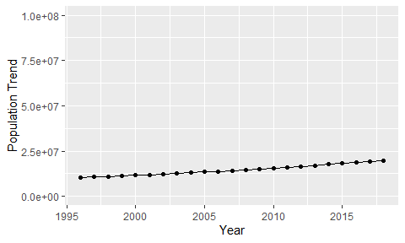

Political Stability Trend

# Population growth graph

The plot shows the population growth rate trend of the country.

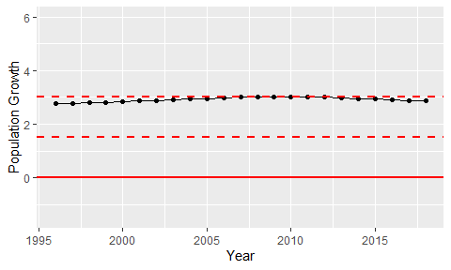

Population Growth Trend